* Task 1: Provision the lab environment
* Task 2: Configure local and global virtual network peering
* Task 3: Test intersite connectivity

Task 1: Provision the lab environment

select **PowerShell and upload the**  **az104-05-vnetvm-loop-template.json** and **az104-05-vnetvm-loop-parameters.json**

**After this run these commands**

$location1 = 'eastus'

$location2 = 'westus'

$rgName = 'az104-05-rg1'

New-AzResourceGroup -Name $rgName -Location $location1

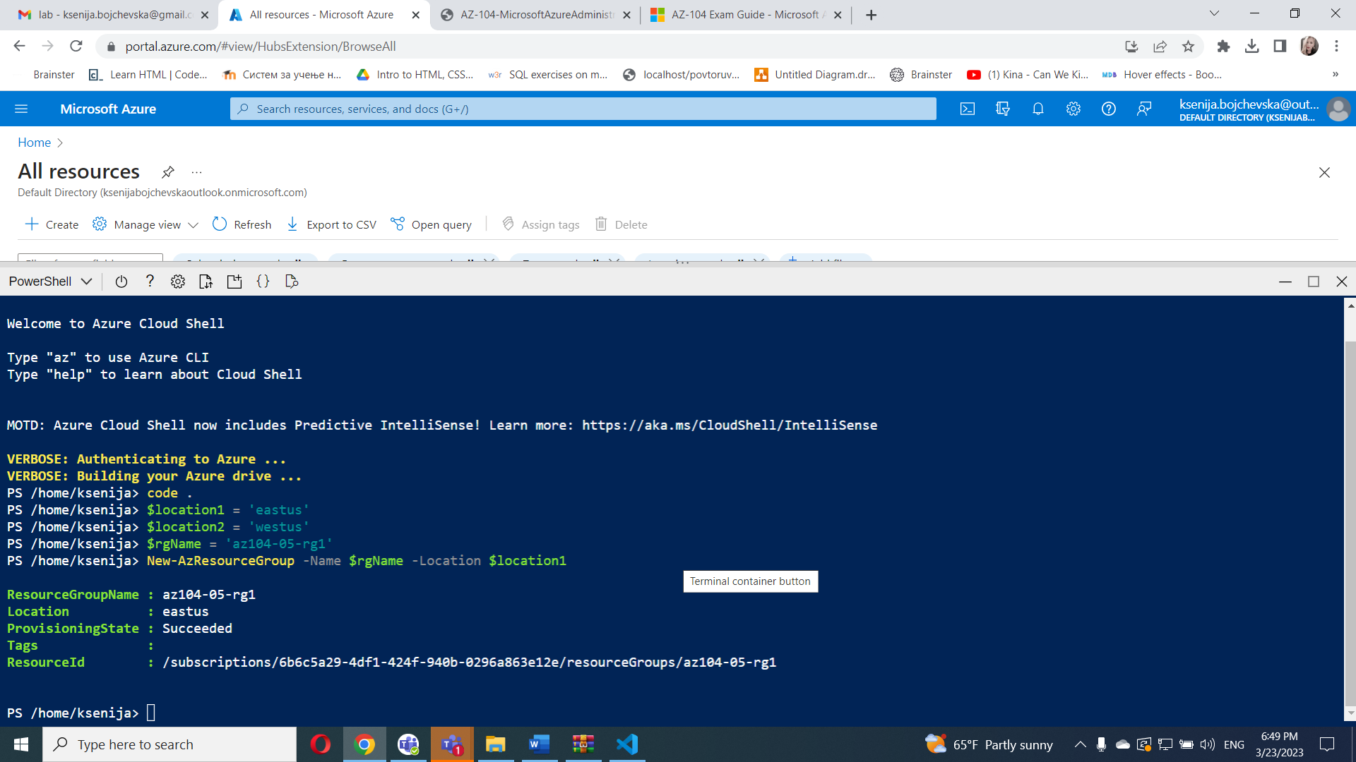

And **these commands**

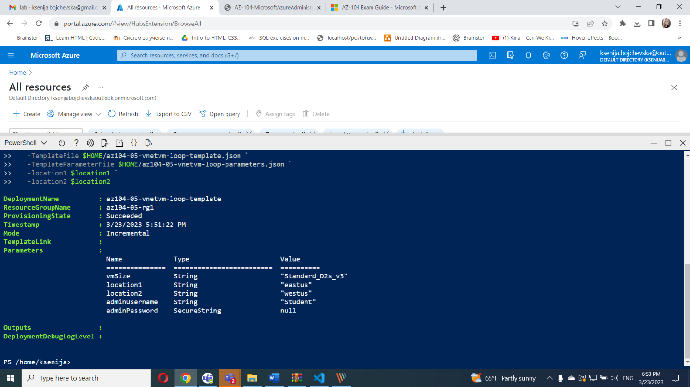

#### Task 2: Configure local and global virtual network peering

 Select **Virtual networks**

Review the virtual networks you created in the previous task and verify that the first two are located in the same Azure region and the third one in a different Azure region

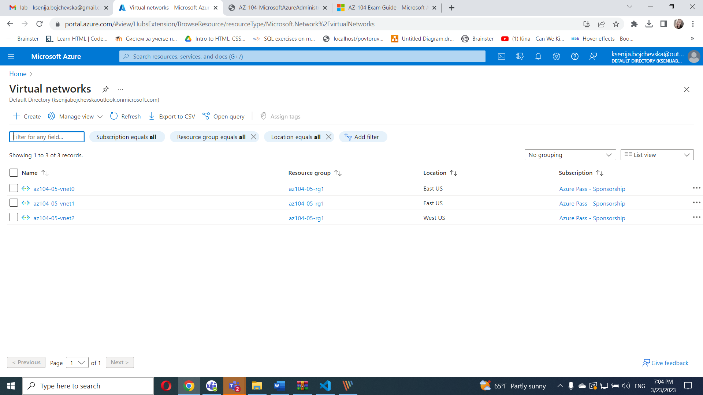

On the **az104-05-vnet0** virtual network blade, in the **Settings** section, click **Peerings** and then click **+ Add**.

I created from powershell commands

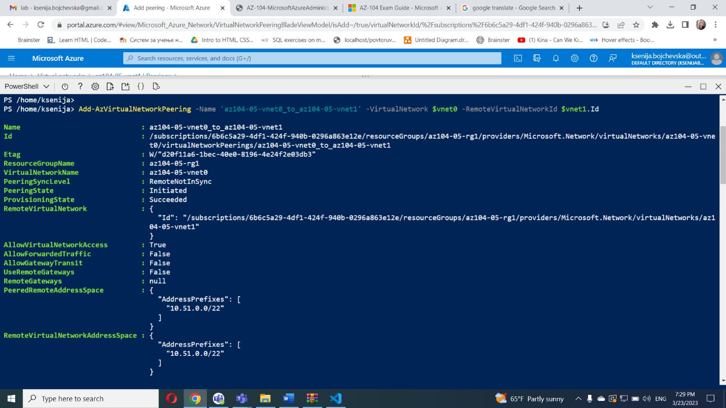

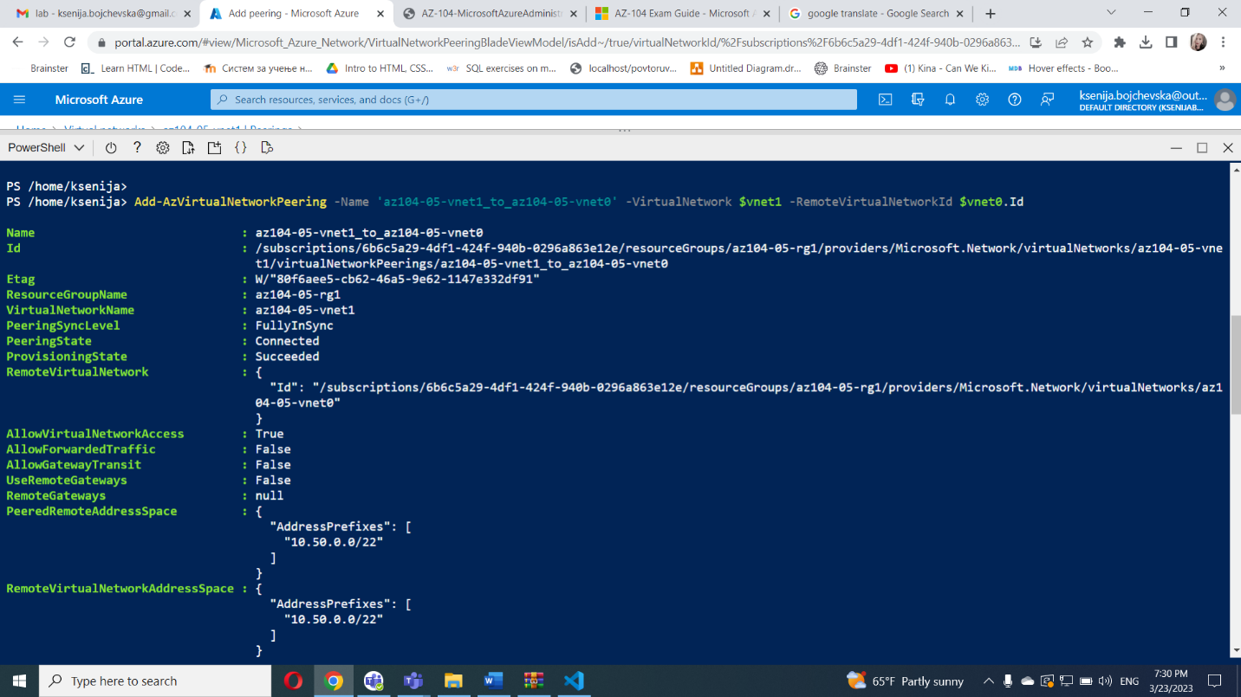

On the **az104-05-vnet1** virtual network blade, in the **Settings** section, click **Peerings** and then click **+ Add**.

I created from powershell commands

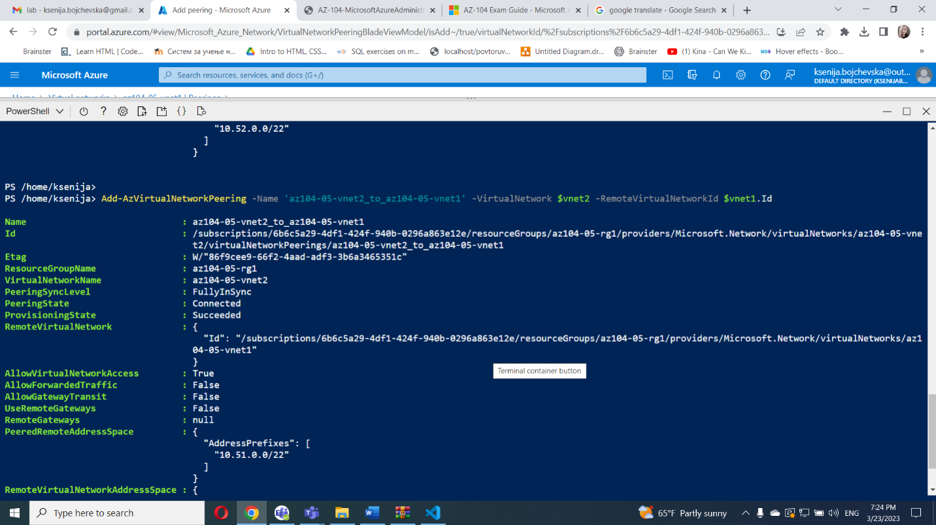



#### Task 3: Test intersite connectivity

select **Virtual machines**

On the **az104-05-vm0** blade, click **Connect**, in the drop-down menu, click **RDP**, on the **Connect with RDP** blade, click **Download RDP File**

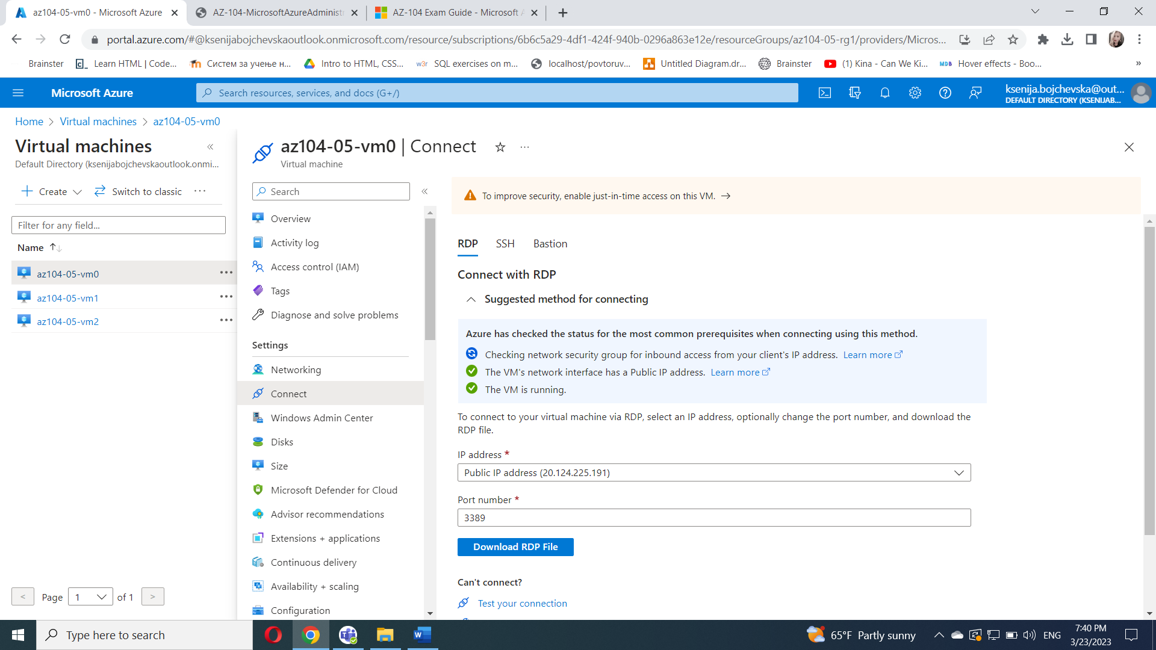

In the Windows PowerShell console window, run the following to test connectivity to **az104-05-vm1** (which has the private IP address of **10.51.0.4**) over TCP port 3389:

Use this command

Test-NetConnection -ComputerName 10.51.0.4 -Port 3389 -InformationLevel 'Detailed'

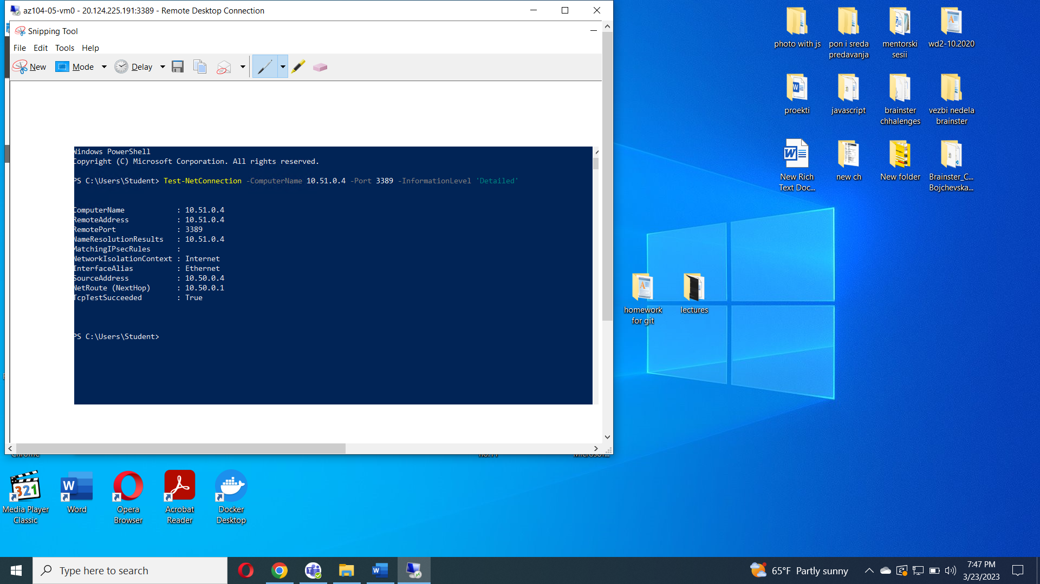

And

Test-NetConnection -ComputerName 10.52.0.4 -Port 3389 -InformationLevel 'Detailed'

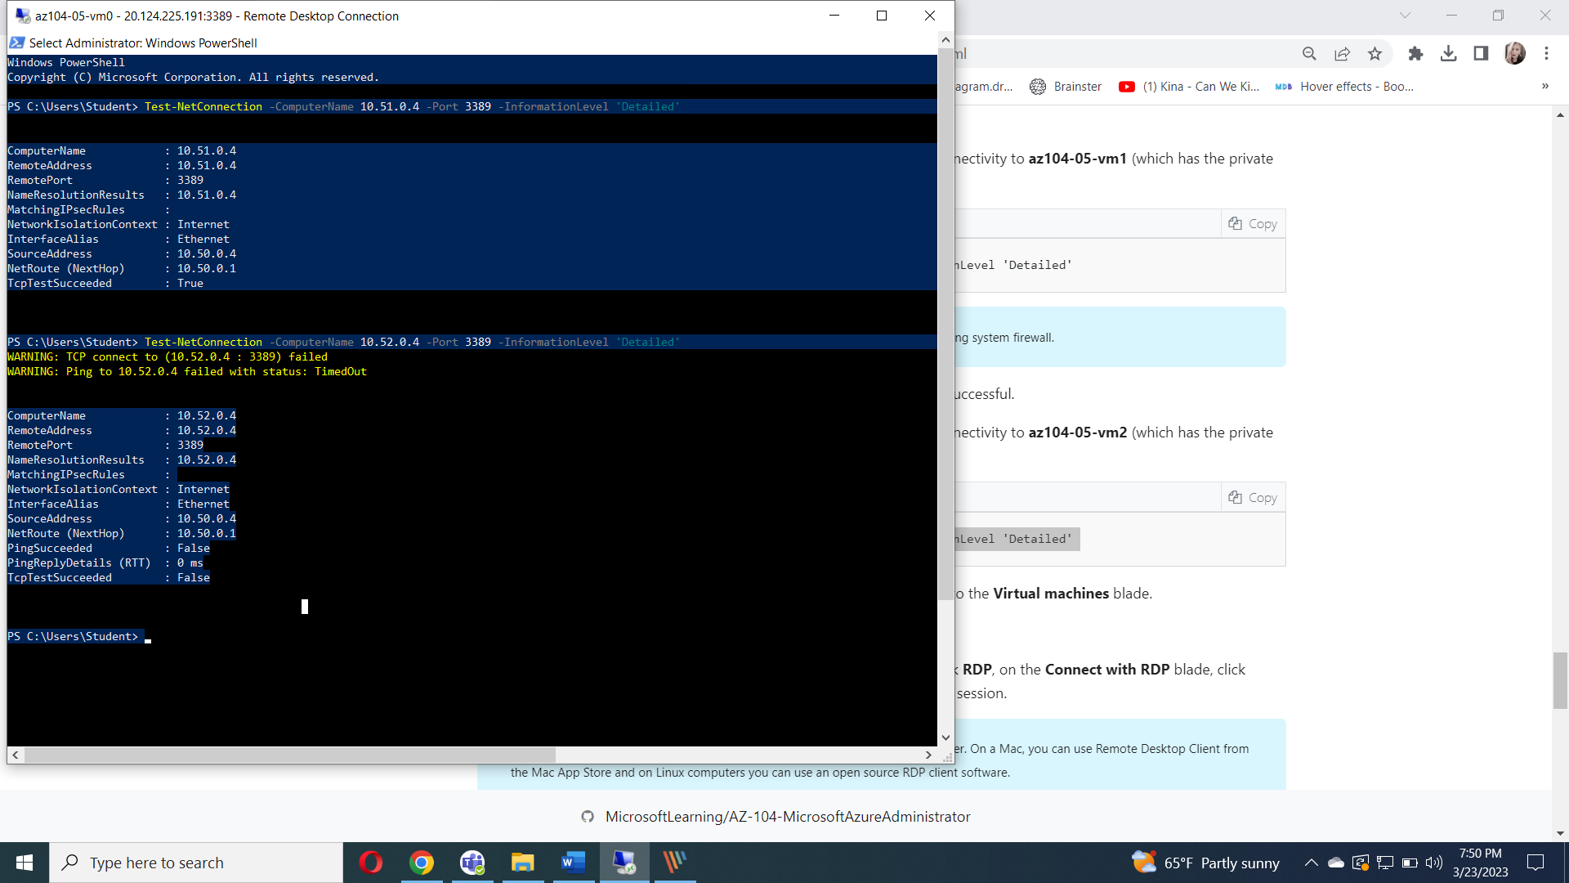

In  **Virtual machines** blade, I n the list of virtual machines, click **az104-05-vm1**,on the **az104-05-vm1** blade, click **Connect**, in the drop-down menu, click **RDP**, on the **Connect with RDP** blade, click **Download RDP File** and follow the prompts to start the Remote Desktop session.

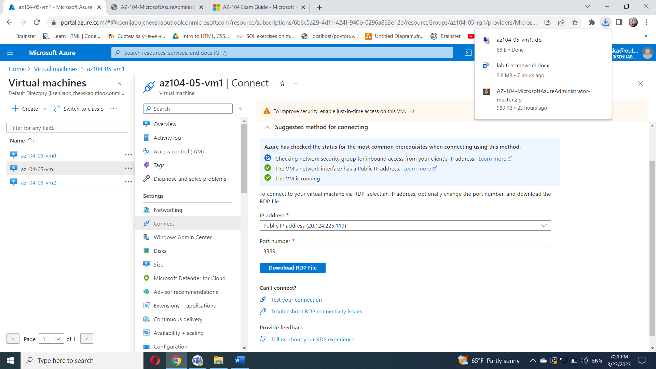

1. Within the Remote Desktop session to **az104-05-vm1**, right-click the **Start** button and, in the right-click menu, click **Windows PowerShell (Admin)**.

In the Windows PowerShell console window, run the following to test connectivity to **az104-05-vm2** (which has the private IP address of **10.52.0.4**) over TCP port 3389:

And run this command

Test-NetConnection -ComputerName 10.52.0.4 -Port 3389 -InformationLevel 'Detailed'

